Functional annotation of proteins with comparative modelling of TP53 of Bos Taurus

Rambaldelli Guglielmo UniBo

ABSTRACT
We planned to model and annotate the product of TP53 of Bos Taurus.
We confirmed the belonging of our target protein to the P53 family but unfortunately some region of P53 are not crystallized and so we were able to model only the DNA binding domain and, with less certainty the tetramerization domain.
In the end we were able to transfer the GO terms concerning the DNA binding function but given the high identity with also the other region we think that also the other function might be conserved.

1 - INTRODUCTION

P53 binds the DNA in case of damage and induce the the transcription of cell-cycle and apoptotic factor; it one of the main gene that we found mutated in case of cancer because of this cancer preventing function.

Because of this it is a widely studied protein in humans and the comprehensions of its functionality can lead to great improvement in cancer preventing therapy.

The aim of this work was to model and annotate the P53 of Bos Taurus P67939.

The gene TP53 of Bos Taurus is present in the UniProt[3] database as a p53 but it is not present a 3D structure, our aim is to manually annotate the protein and make a reliable model of it.

It has different domain[8]:
1 - an acidic N-terminus transcription-activation domain (TAD), also known as activation domain 1 (AD1), which activates transcription factors. The N-terminus contains two complementary transcriptional activation domains.
2 - activation domain 2 (AD2) important for apoptotic activity.
3 - proline rich domain important for the apoptotic activity of p53 by nuclear exportation via MAPK.
4 - central DNA-binding core domain (DBD). Contains one zinc atom and several arginine amino acids. This region is responsible for binding the p53 co-repressor LMO3.
5 - Nuclear Localization Signaling (NLS) domain.
6 - homo-oligomerisation domain (OD).
Tetramerization is essential for the activity of p53 in vivo.
7 - C-terminal involved in downregulation of DNA binding of the central domain.

2 – METHOD

2.1 – DataBase
The known sequence has been aligned with UniProtKB[3] trought BLAST[1] (E 0.1) to find a template, The most suited one are 4MZR and 3Q05, the second has been chosen because even if the 4MZR has better coverage after trying the modelling in became clear that the flexible part of the protein was not possible to be decently modelled.
The data regarding the template has been collected in PDB[2] and the annoation for it in UniProt[3] P04637.

2.2 – Computational Method
Our sequence has been aligned with 4mzr with Lalign[4] using a global alignment BLOSOM 62.
Five model has been made by omology using Modeller[5], than the hypotetical structure has been contolled with ProCheck [6] and superimposed to the template using Chimera[8].
Finally the manual revision has been done using Chimera.

3 - TEMPLATE SELECTION

As a template has been chosen 3Q05 and we aligned the two protein with Needleman and wush algorythm using a BLOSOM 63 matrix with Lalign(FIG. 3.1) .

We chose 3Q05 as a template because of the high identity (85.3%) and similarity (93.5%) for the DNA dinding domain of the target, the fact that 4MZR is annotated as a P53 in SwissProt[3] and so has the same type of functional site as the target suggesting the appartenence of the target to the familiy.
Moreover there is the experimentally determined crystalline structure unfortunatly with a resolution of 2.4 Armstrong.

The N-terminal region before the DNA binding domain where removed, 29 amminoacids were also removed from the target because thay were used for cristallization purpose and also a few residues on the C-terminal.

The coverage is 69.2% Unfortunatly there aren't any P53 model comprensive of the other domain.

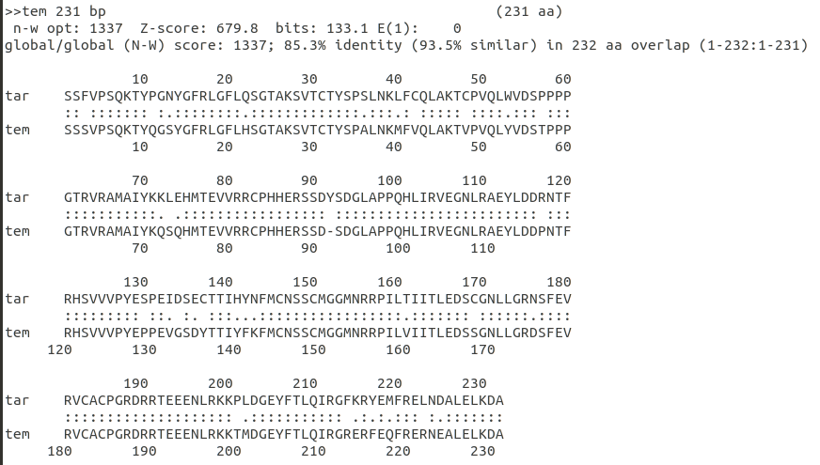
FIG. 3.1: Sequence alignment
of the template (3Q05) and the target protein

4 – MODELLER

Starting from the alignment we created a PIR file and then we modified a few thing:
1-PIR file: Added zinc atom to the alignment.
2-PDB file: Modified the PDB file to incorporate the zinc atom.

Then we executed Modeller trought a Python script producing five different model(FIG. 4.1\2) for the chain B\C and other five for the chain A\D and from the internal validation of modeller model 3 seems the best one for A\D and model for 4 B\C.
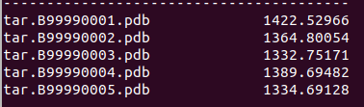

FIG. 4.1: Molpdf of the five model generated for A\D.

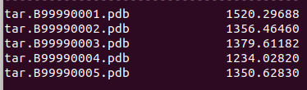
FIG. 4.2: Molpdf of the five model generated for B\C.

5 - PROCHECK
The created models has been check with procheck to analyze the dihedral angle and the resulting stability.

A\D MODELS:
1-MODEL
Ramachandran plot: 94.0% core 5.5% allow 0.5% gener 0.0% disall

2-MODEL
Ramachandran plot: 94.5% core 4.5% allow 0.5% gener 0.5% disall

3-MODEL
Ramachandran plot: 93.5% core 6.0% allow 0.5% gener 0.0% disall

4-MODEL
Ramachandran plot: 94.0% core 5.5% allow 0.5% gener 0.0% disall

5-MODEL
Ramachandran plot: 91.0% core 8.5% allow 0.0% gener 0.5% disall

B\D MODELS:
1-MODEL
Ramachandran plot: 93.0% core 6.0% allow 0.5% gener 0.5% disall

2-MODEL
Ramachandran plot: 91.5% core 7.5% allow 1.0% gener 0.0% disall

3-MODEL
Ramachandran plot: 90.5% core 8.5% allow 0.5% gener 0.5% disall

4-MODEL
Ramachandran plot: 92.0% core 7.5% allow 0.5% gener 0.0% disall

5-MODEL
Ramachandran plot: 92.5% core 6.0% allow 1.0% gener 0.5% disall

In the end Model 3 was chosen for A\D and model 4 for B\C because of the lower modeller score indicating a lesser RMSD to the template and a good fit in the Ramachandra plot leaving the least residue in unfavorable conformation.

The Ramachandran plot show us a good folding, the few residues incompatible with the folding are not in the active site and the majority of the others are compatible with the structure meaning the the protein will have a good stability.

6 - TARGET ANNOTATION

Chimera was used to superimpose the model to te template, we obteained a RSMD of 0.438 Armstrong for D\A and 0295 Armstrong for B\C with identity (85.3%) and similarity (93.5%) suggesting functional similarity.
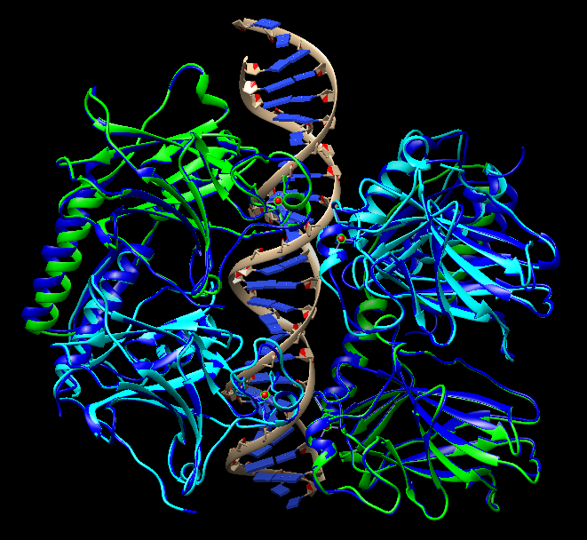

FIG. 6.1: Complete structure
superimposition

6.1 – RELATIVE DISTANCE
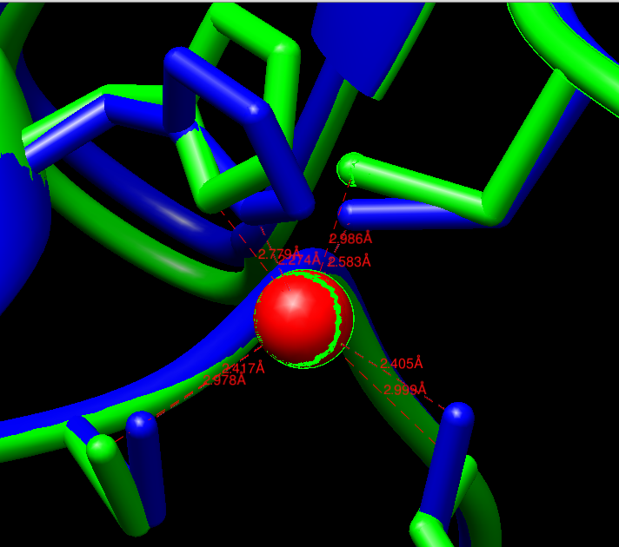

We check if structure of the active site was conserved and measured the relative distances of the zinc:
The Zn in D\A is almost perfectly superimposed (0,05Å).

FIG. 6.2: Zn in the active site of D\A.

The Zn in B\C is have a higher distance in the superimposition (0,158Å).
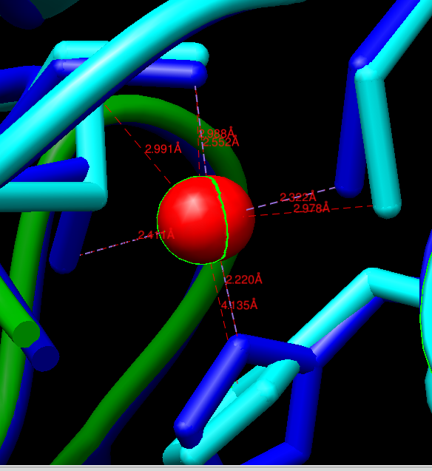

FIG. 6.3: Zn in the active site of
B\C.

6.2 - DISULFITE BONDS
All the CYS are conserved so the dysulfite bond are conserved too, there are a few more CYS in the model that can create bonds but are outside the active site.

6.3 – GLYCOSYLATION

All the ASN are conserved so the glycosilation are conserved.

6.4 – IMPORTANT RESIDUES

All the important residue that interacts with the DNA strand are conserved(LYS 120, SER 121, ARG 280, ARG 283, CYS 277)

As we can see the sequence after the superimposition fit really well the template:
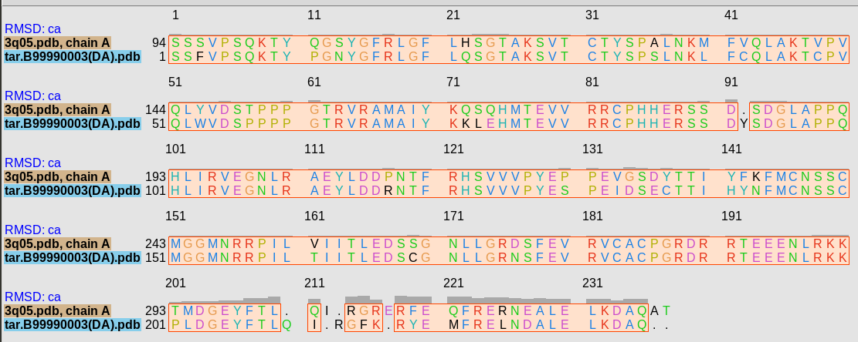

So we can say that our proteine is definitly a P53 and we can also say that the active site have the same structure and functionality.

7 - FUNCTIONAL ANNOTATION

From the result of the omology modelling we can say that the active site is conseved and so our target is a P53.
So we can transfer the GO annotation concerning the DNA Binding region from the modell to the target, probably also the GO term referring to the rest of the protein can be transfer given the high identity but it should be investigated better with other methods.

8 – RESULTS AND DISCUSSION

Even if the template avable for P53 did not have a very good resolution we were able to reach a decent model for our protein.
We have seen that the Zn in the active site and the residues near it are conserved and so the active site necassary to bind the DNA is functional.
Moreover the structure of the protein have an high similarity to the template P53 so probably also the other domain are conserved.

9 - REFERENCE

[1] BLAST at NCBI
Paper: PMID: 2231712
Release: 2.8.1: December 13, 2018
Link: https://blast.ncbi.nlm.nih.gov/Blast.cgi

[2] RCSB PDB
Authors: H.M. Berman, J. Westbrook, Z. Feng, G. Gilliland, T.N. Bhat, H. Weissig, I.N. Shindyalov, P.E. Bourne.
Paper: The Protein Data Bank Nucleic Acids Research, 28: 235-242.
Release: February 2016
Link: https://www.rcsb.org/

[3] UniProt
Paper: UniProt: the universal protein knowledgebase Nucleic Acids Res. 45: D158-D169 (2017)
Release: 2018_11 (05-Dec-2018)
Link: https://www.uniprot.org/

[4] Lalign
Author: William Pearson
The lalign program implements the algorithm of Huang and Miller, published in Adv. Appl. Math. (1991) 12:337-357.
Link: https://embnet.vital-it.ch/software/LALIGN_form.html

[5] Modeller
Author: Andrej Sali
Paper: A. Sali & T.L. Blundell. Comparative protein modelling by satisfaction of spatial restraints. J. Mol. Biol. 234, 779-815, 1993.
Release: 9.21, which was released on Dec 11th, 2018
Link: https://salilab.org/modeller/

[6] ProCheck at EMBL-EBI
Authors: Laskowski R A, MacArthur M W, Moss D S & Thornton J M (1993).
Paper: PROCHECK: a program to check the stereochemical quality of protein structures. J. Appl. Cryst., 26, 283-291.
Link: https://www.ebi.ac.uk/thornton-srv/software/PROCHECK/

[7] UCSF Chimera
Authors: Pettersen EF, Goddard TD, Huang CC, Couch GS, Greenblatt DM, Meng EC, Ferrin TE. J Comput Chem. 2004 Oct;25(13):1605-12.
Paper: UCSF Chimera--a visualization system for exploratory research and analysis.
Release: 1.13.1 17 november 2018
Link: https://www.cgl.ucsf.edu/chimera/

[8] Pfam
Authors: S. El-Gebali, J. Mistry, A. Bateman, S.R. Eddy, A. Luciani, S.C. Potter, M. Qureshi, L.J. Richardson, G.A. Salazar, A. Smart, E.L.L. Sonnhammer, L. Hirsh, L. Paladin, D. Piovesan, S.C.E. Tosatto, R.D. Finn
Paper: The Pfam protein families database in 2019
Link: https://pfam.xfam.org/

